Tomato and vegetable pasta bake recipe
Ingredients  - 1 tbsp olive or veg oil  - 1 onion  - 1 carrot  - 1 garlic clove  - 1 tbsp balsamic vinegar  - 1 tbsp dried oregano  - 1 x 400g tins chopped tomatoes  - 250g penne  - 100g mature Cheddar | 

Method
Cook the pasta in a large saucepan of boiling salted water for 8–10 minutes. | 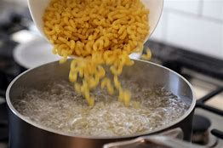
Peel and dice the onion  Peel and crush the garlic |   
Cut the pepper in half and remove the seeds  Dice the pepper | 
Peel the carrot  Grate the carrot | 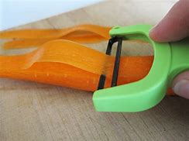  
Heat the oil in a pan  Add the chopped up the vegetables and cook for a few minutes | 
Add the vinegar and herbs mix well  Add the tin of chopped tomatoes and cook for a few minutes | 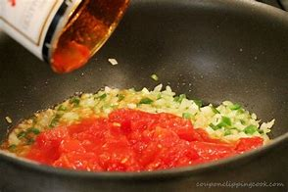
Add the sauce to the cooked pasta and mix well | 
Pour the pasta into an oven proof dish | 
Grate cheese | 
Sprinkle over the pasta | 
Place in a hot oven for 15-20mins until cheese has melted and golden | 

