Hash brown Recipe
Ingredients  - 1 large potato  - 1 egg  - 2 tablespoons vegetable oil | 
Scrambled egg ingredients  Eggs  Milk  Salt and pepper  Butter cooking | 

Method
Peel the potato | 
Grate the potato using the large side of the grater | 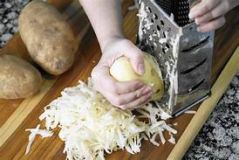
Place the potato onto a clean tea towel and squeeze as much of the starch out as you can | 
Place the potato in a bowl and add 1 egg, mix well | 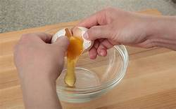
Take a handful of mixture and shape into a Pattie repeat this until the mixture is finished | 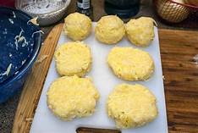
Heat the vegetable oil in a frying pan  Fry each Pattie until golden brown – 2-3 mins…… then turn over and cook on the other side | 